Disturbed Serum Levels of Adipocytokines may underlie the development of Uterine Leiomyoma
Wagdy M Amer MD⁽¹⁾, Ali A Morsi MD⁽¹⁾, Hamasat A Alnoury MD⁽²⁾
Department of Obstetrics & Gynecology, Faculty of Medicine, Benha University ⁽¹⁾
Department of Clinical science, Faculty of Medicine, King salman International University⁽²⁾
Department of Clinical and chemical pathology, Faculty of Medicine, Benha University⁽²⁾
Abstract
Objectives: To evaluate the relation between serum adipocytokines' levels and the development of uterine leiomyoma (UL) in symptomatic (Group II) or asymptomatic (Group III) women.
Patients & Methods: 60 women presenting by pelvic pressure manifestations, secondary infertility, or recurrent pregnancy loss (RPL) with (Group II) or without (Group III) abnormal uterine bleeding (AUB) were enrolled in the study. Thirty women who UL-free and were of cross-matched age and BMI to were collected as control group (Group I). All women underwent complete clinical and ultrasonographic evaluation and gave blood samples for ELISA estimation of serum tumor necrosis factor-α (TNF-α), adiponectin and leptin
Results: Serum levels of TNF-α and leptin were significantly higher in samples of women of group II in comparison to levels estimated in blood samples of women of group I and III with significantly higher levels in blood samples of women of group III than in group I. Serum levels of adiponectin estimated in blood samples obtained from patients of groups II and III were significantly lower than in samples of group I with non-significant differences between levels estimated in samples of groups II and III. Statistical analyses defined high serum TNF-α and leptin as significant positive predictors, while high serum adiponectin was a significant negative predictor for UL presence. The Automatic Linear Modeling analysis defined high serum levels of TNF-α as the most important predictor for presence of UL and its manifestations.
Conclusion: The prevalence of UL is high and may not be present by AUB but disturbed fertility. Development of UL might be considered as a consequent event to disturbed adipocytokines levels. Estimation of serum TNF-α in woman suspected to have UL is indicated for its diagnostic probability and relation to the multiplicity of symptoms.
Keywords: Uterine leiomyoma, Tumor necrosis factor-α, Adiponectin, Leptin, Prediction of leiomyoma presence
Introduction
Uterine leiomyoma (UL) is one of the most common benign pelvic tumors in females of reproductive years that originates from mesenchymal or connective tissues ⁽¹⁾. Despite the high prevalence of UL, its underlying pathogenesis is not fully elucidated ⁽²⁾.
Multiple mechanisms were supposed for the development of uterine smooth muscle tumors as early-life exposure of the myometrium to endocrine-disrupting chemicals that were found to be associated with a high risk of UL prevalence in adulthood ⁽³⁾. Also, the metabolites of di(2-Ethylhexyl)phthalate, which is a reproductive and developmental environmental toxicant, showed significant direct associations with the development of benign uterine and ovarian tumors ⁽⁴⁾. Also, the development of a benign tumor of the uterine smooth muscles was found to be related to hypovitaminosis D ⁽⁵⁾ and disturbed inflammatory/anti-inflammatory axis in direction of inflammation and ⁽⁶⁾.
Tumor necrosis factor (TNF) is a prototypic member of the TNF/TNFR superfamily ⁽⁷⁾, which comprises 19 ligands and 30 receptors, all of which represent a therapeutically relevant target in a wide range of human diseases ⁽⁸⁾. The TNF-alpha (TNF-α) gene is present as a single copy gene on human chromosome 6 (9) and its expression is regulated at the transcriptional level by several factors, including nuclear factor-kappa b (NFκB) and nuclear factor activated T cells ⁽¹⁰⁾. Also, TNF-α production is regulated at the translational level via the UA-rich sequence in the 3′ untranslated region of human TNFα mRNA ⁽¹¹⁾.
TNF-α is a pleiotropic cytokine that can be produced by different cell types ⁽¹²⁾. TNF-α is one of the adipocyte-derived proteins including leptin, insulin, and interleukin (IL)-6 ⁽¹³⁾ and all are capable of significantly influencing the growth and proliferation of tumor stroma and malignant cells ⁽¹⁴⁾ through increasing the expression of vascular endothelial growth factor-A ⁽¹⁵⁾.

Objectives
This study aimed to evaluate the relationship between adipose tissue secreted adipocytokines and the development of UL in symptomatic or asymptomatic women.

Setting:
Prospective comparative observational study

Design:
Obstetrics and Gynecology Department, Faculty of Medicine, Benha University

Patients & Methods
Women presented with abnormal uterine bleeding (AUB), pelvic pressure manifestations, secondary infertility, or recurrent pregnancy loss (RPL) to gynecology outpatients' clinics since Jan 2020, were eligible for evaluation. All women were evaluated for age, weight, and height for calculation of body mass index (BMI) in kg/m² and family, medical and obstetric history. Details of the presenting symptoms were inquired and clinical examination was performed and ultrasound imaging workup was conducted.
Exclusion criteria
Intrauterine pathologies other than UL, endocrinopathy causing dysfunctional uterine bleeding, urinary pathologies causing mimicking symptoms, overt diabetes mellitus, coagulopathies, inflammatory conditions elsewhere in the body.
Inclusion criteria and Grouping
- Women who presented with AUB and other clinical manifestations suggestive of the presence of UL and US findings assured its presence and were free of other pathologies causing similar clinical picture were enrolled as UL symptomatic group (Group II).
- Women who presented by secondary infertility, RPL, or pelvic pressure manifestations and were free of AUB, but UL was discovered during US imaging, and were free of exclusion criteria and were of cross-matched age and BMI to women of group II were collected as asymptomatic group UL (Group III).
- A similar number of women who were free clinically and on US imaging of UL and were of cross-matched age and BMI to women of group II were collected as the control UL-free group (Group I)

Laboratory investigations
Blood sampling
All study participants gave a 5 ml blood sample that was withdrawn under complete aseptic conditions, allowed to clot, and then centrifuged at 3000 rpm for 10 minutes to separate serum. Serum was collected in a sterile Eppendorf tube and stores at -80ºC till be assayed. Blood samples were collected and numbered by an assistant who was blinded about the diagnosis.
Laboratory investigations
Serum levels of TNF-α, adiponectin, and leptin were measured using enzyme-linked immunosorbent assay (ELISA) kits according to the manufacturer's instructions and were read using a 96 well microplate ELISA reader (Dynatech. MR 7000)
- Human TNF-α was measured with the enzyme-linked immunoassay (ELISA) kit (catalog no. ab181421, Abcam Inc., San Francisco, USA) by quantitative sandwich enzyme immunoassay technique ⁽¹⁶⁾.
- Human adiponectin was measured with the enzyme-linked immunoassay (ELISA) kit (catalog no. ab99968, Abcam Inc., San Francisco, USA) by quantitative sandwich enzyme immunoassay technique ⁽¹⁷⁾.
- Human leptin was measured with the enzyme-linked immunoassay (ELISA) kit (catalog no. ab179884, Abcam Inc., San Francisco, USA) by quantitative sandwich enzyme immunoassay technique ⁽¹⁸⁾.

Statistical analysis
Obtained data were presented as mean, standard deviation, numbers, and percentages. Results were analyzed using One-way ANOVA for analysis of variance between groups, and Mann-Whitney and Chi-square tests (X² test) for analysis of non-numeric data. Spearman's correlation analysis was applied to evaluate correlations between studied variables. Receiver characteristic curve (ROC) analysis was used to determine the predictors of presence of UL among the correlated variables as judged by the area under curve (AUC) with the its significance was evaluated versus the standard curve (AUC=0.5). The automatic linear modeling analysis was used to determine the importance of the variables for prediction of outcomes. Statistical analysis was conducted using IBM® SPSS® Statistics (Version 22, 2015; Armonk, USA) for Windows statistical package. P value <0.05 was considered statistically significant.

Results
During the study duration, 43 women had presented with symptomatic UL (AUB & other manifestations) that was assured by US imaging; 13 women were excluded for not fulfilling the inclusion criteria and 30 women were enrolled in group II. Fifty-eight women free of AUB and had UL on US imaging were evaluated, 28 women were excluded and 30 women were included as group II (Fig. 1).

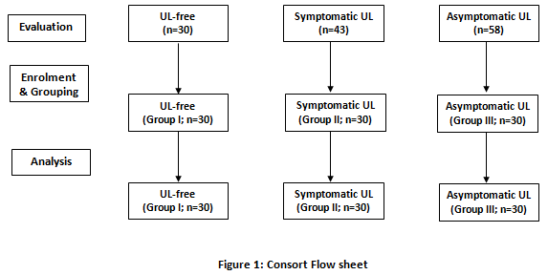

There were non-significant differences between the enrolled women as regards age, BMI, and several previous pregnancies; however, women of group II had significantly lower and women of group III had a non-significantly lower number of living offspring in comparison to women of group I (Table 1).

Table 1: Enrolment data of patients of the three groups

Variable |  | Group I (UL-free) | Group II (Symptomatic UL) | Group III (asymptomatic UL) | Significance of difference between groups
 |  |  |  |  | I vs. II | I vs. III | II vs. III
Age (years) |  | 37±3.9 | 39.4±5.6 | 40.4±4.1 | 0.111 | 0.139 | 0.675
Weight (kg) |  | 91.6±7.7 | 93.7±6.1 | 92.4±7.5 | 0.489 | 0.901 | 0.759
Height (cm) |  | 169.5±3.5 | 170.2±2.5 | 169.4±3.5 | 0.677 | 0.992 | 0.601
BMI* (kg/m²) | <30 | 7 (23.3%) | 5 (16.7%) | 4 (13.3%) | 0.779 | 0.511 | 0.895
 | 30-35 | 20 (66.7%) | 21 (70%) | 21 (21%)
 | >35 | 3 (10%) | 4 (13.3%) | 5 (16.7%)
 | Mean | 31.2±3.5 | 32.4±2.3 | 32.2±2.7 | 0.136 | 0.215 | 0.828
Gravidity ǂ |  | 3 [2-3] | 3 [2-4] | 3 [2-4] | 0.187 | 0.379 | 0.603
Living offspring ǂ |  | 3 [2-3] | 2 [1-3] | 2 [2-3] | 0.041 | 0.054 | 0.697
Data are presented as mean and standard deviation, numbers and percentages, median and interquartile range [IQR]ǂ; BMI: Body mass index; *: BMI<30 indicate overweight; BMI30-35: indicates obesity; BMI: >35 indicates morbid obesity; P1: indicates the significance of the difference between groups I & II; P2: indicates the significance of the difference between groups I & III; P3: indicates the significance of the difference between groups II & III, P<0.05 indicates the significant difference; P>0.05 indicates the non-significant difference.

All patients of groups II and III were presenting varied symptoms related to the presence of UL, however, the frequency of symptoms and median several symptoms were significantly (P=0.0005 & 0.00038, respectively) higher in patients of group II than in patients of group III. Regarding US findings in patients of groups II and III, there were non-significant differences between both patients of both groups as regards several detected UL, their multiplicity, location, and whether it is sessile or pedunculated (Table 2).

Table 2: presenting symptoms and US data of patients of groups II and III.

 |  |  | Group II (Symptomatic UL) | Group III (asymptomatic UL) | P-value
Presenting symptoms
Dysmenorrhea |  |  | 7 (26.7%) | 5 (16.7%) | 0.0005
Bleeding | Polymenorrhea |  | 13 (43.3%) | 0
 | Menorrhagia |  | 10 (33.3%) | 0
 | spotting in between cycles |  | 7 (23.3%) | 0
Secondary infertility |  |  | 6 (20%) | 7 (23.3%)
Urinary troubles |  |  | 12 (30%) | 13 (43.3%)
Rectal troubles |  |  | 8 (33.3%) | 8 (26.7%)
Recurrent pregnancy loss |  |  | 4 (13.3%) | 6 (20%)
Median number of symptoms ǂ |  |  | 2 [1-3] | 1 [1-1.25] | 0.00038
US findings
Number of the ultrasound detected UL |  | Solitary | 18 (60%) | 23 (76.6%) | 0.328
 |  | Two | 7 (23.3%) | 5 (16.7%)
 |  | Multiple | 5 (16.7%) | 2 (6.7%)
 |  | Median [IQR] | 1 [1-2] | 1 [1-1.25] | 0.231
Location of the ultrasound detected UL |  | Intramural | 7 (23.3%) | 15 (50%) | 0.095
 |  | Submucous | 19 (63.4%) | 13 (43.3%)
 |  | Subserosal | 4 (13.3%) | 2 (6.7%)
Shape of the ultrasound detected UL |  | Pedunculated | 7 (23.3%) | 4 (13.3%) | 0.317
 |  | Sessile | 23 (76.7%) | 26 (86.6%)
Data are presented as numbers and percentages, mean and standard deviation, median and interquartile range (IQR) ǂ; P: indicates the significance of the difference between groups II & III, P<0.05 indicates the significant difference; P>0.05 indicates the non-significant difference.

Serum levels of TNF-α and leptin estimated in blood samples obtained from patients of group II were significantly higher in comparison to levels estimated in blood samples of women of group I (P1<0.001, respectively) and in blood samples of women of group III (P3<0.001, respectively). Similarly, serum levels of TNF-α and leptin estimated in blood samples obtained from patients of group III were significantly higher in comparison to levels estimated in blood samples of women of group I (P2=0.001 & 0.035 respectively). On the other hand, serum levels of adiponectin estimated in blood samples obtained from patients of groups II and III were significantly lower in comparison to levels estimated in blood samples of women of group I (P1 & P2<0.001, respectively) with non-significantly (P3=0.404) lower serum levels of adiponectin in blood samples of patients of group II in comparison to levels estimated in blood samples of patients of group III, (Table 3; Figures 2).

Table 3: Laboratory findings in samples obtained from patients of the three groups

Variable | Group I (UL-free) | Group II (Symptomatic UL) | Group III (asymptomatic UL) | Significance of difference between groups
 |  |  |  | P1 | P2 | P3
Serum TNF-α level (ng/ml) | 4.62±0.9 | 7.25±1.3 | 5.7±1 | <0.001 | 0.001 | <0.001
Serum adiponectin level (ng/ml) | 16.3±2.9 | 11.55±3.1 | 12.6±3.1 | <0.001 | <0.001 | 0.404
Serum liptin level (ng/ml) | 5.8±1.85 | 12.9±3.2 | 7.34±1.7 | <0.001 | 0.035 | <0.001
Data are presented as a mean and standard deviation; TNF: Tumor necrosis factor; P1: indicates the significance of the difference between groups I & II; P2: indicates the significance of the difference between groups I & III; P3: indicates the significance of the difference between groups II & III, P<0.05 indicates the significant difference; P>0.05 indicates the non-significant difference.

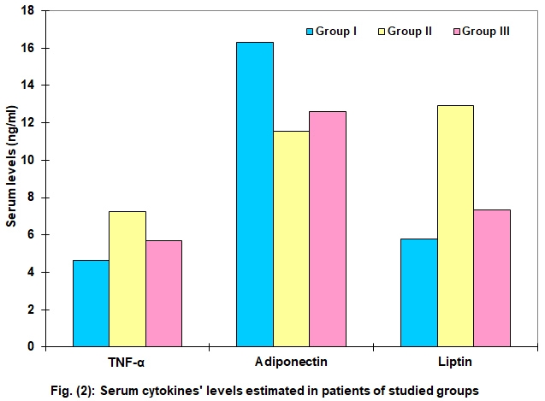

Spearman's correlation analysis defined a positive significant correlation between older age, high serum levels of TNF-α and leptin, while the defined negative significant correlation between serum adiponectin levels and diagnosis of UL especially multiple myomata, irrespective of being symptomatizing or not and with the multiplicity of symptoms if present. Spearman's correlation analysis illustrated the deleterious effect of the presence of UL especially if symptomatizing as manifested by a negative significant correlation between the presence of UL especially that symptomatizing and with multiple presenting symptoms and number of living offspring (Table 4).

Table (4): Spearman's correlation analysis of age, BMI, obstetric histories and serum cytokines' levels and presence of UL and its related manifestations.

Variables | Presence of UL |  | Multiplicity of UL |  | Symptomatizing UL |  | Multiplicity of symptoms
 | Rho. | p | Rho. | p | Rho. | p | Rho. | p
Age | 0.366 | <0.001 | 0.382 | <0.001 | 0.183 | 0.084 | 0.414 | <0.001
BMI | 0.117 | 0.272 | 0.125 | 0.242 | 0.078 | 0.465 | 0.132 | 0.213
Gravidity | 0.143 | 0.180 | 0.288 | 0.006 | 0.119 | 0.263 | 0.271 | 0.010
No. of living offspring | -0.265 | 0.011 | -0.215 | 0.042 | -0.163 | 0.125 | -0.211 | 0.046
Serum TNF-α | 0.597 | <0.001 | 0.587 | <0.001 | 0.638 | <0.001 | 0.568 | <0.001
Serum adiponectin | -0.557 | <0.001 | -0.468 | <0.001 | -0.378 | <0.001 | -0.487 | <0.001
Serum leptin | 0.590 | <0.001 | 0.637 | <0.001 | 0.777 | <0.001 | 0.621 | <0.001
Rho: Spearman's correlation coefficient; UL: Uterine leiomyoma; BMI: Body mass index; TNF-α: Tumor necrosis factor-α.

ROC curve analysis of patient's demographic and clinical data and serum cytokines' levels for prediction of the presence of UL excluded BMI and multigravidity as predictors and stratified the other variables in decreasing order of significance as high serum level of TNF-α and leptin and older age as the significant specific according to AUC which signifies the positive predictive value of each variable, and defined low serum levels of adiponectin as the significant sensitive predictor for the presence of UL (Fig. 3). Moreover, Regression analysis, Stepwise methods, excluded age as a predictor and defined high serum TNF-α and leptin as significant positive predictors, while high serum adiponectin was a significant negative predictor for UL presence (Table 5).

Table (5): ROC curve and Regression analyses.

Analyses  Variables | ROC analysis |  |  |  | Regression analysis
 | AUC | SE | p | 95% CI | Β-value | P
Age | 0.723 | 0.057 | 0.001 | 0.612-0.835 | Excluded
BMI | 0.572 | 0.069 | 0.271 | 0.437-0.706
Gravidity | 0.583 | 0.061 | 0.201 | 0.464-0.702
Serum TNF-α | 0.866 | 0.038 | <0.001 | 0.792-0.939 | 0.257 | 0.022
Serum adiponectin | 0.159 | 0.041 | <0.001 | 0.078-0.240 | -0.339 | <0.001
Serum leptin | 0.861 | 0.039 | <0.001 | 0.786-0.937 | 0.234 | 0.027
AUC: Area under the curve; SE: Standard error; CI: Confidence interval; β: Standardized coefficient; BMI: Body mass index; TNF-α: Tumor necrosis factor-α.

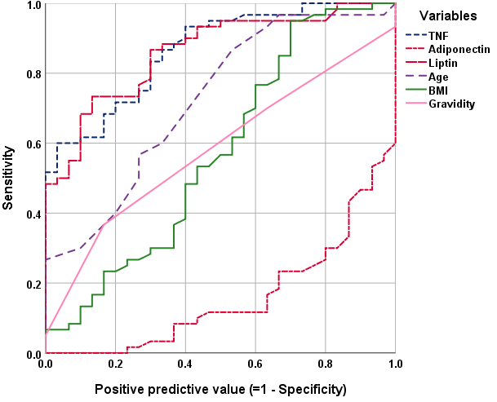
Fig. (3): ROC curve analysis of studied variables for prediction of the presence of UL

The Automatic Linear Modeling analysis of correlated variables concerning its importance for the prediction of the presence of UL and its related manifestations excluded BMI and gravidity as important predictors for the presence of UL and stratified the other variables according to its importance as high serum levels of TNF-α, lower serum levels of adiponectin and high serum levels of leptin and old age in decreasing order of importance (Fig. 4). For prediction of the presence of multiple UL, high serum leptin and older age are the important predictors (Fig. 5), while for the presence of symptomatizing UL high serum level of TNF-α, low serum level of adiponectin, and high BMI are the important predictors (Fig. 6) and high serum TNF-α and leptin, and low serum adiponectin with multigravidity are the important predictors for a multiplicity of presenting symptoms, (Table 6, Figures 4-7).

Table (6): The automatic Linear Modeling analysis for variables as important predictors for the UL presence, multiplicity, and manifestations

Variables | Presence of UL | Multiplicity of UL | Symptomatic UL | Multiplicity of symptoms
Old age | 13% | 41% | Excluded | Excluded
High BMI | Excluded | Excluded | 7%
Multigravidity |  |  | Excluded | 21%
High serum TNF-α | 44% |  | 77% | 44%
Low serum adiponectin | 24% |  | 16% | 10%
High serum leptin | 19% | 59% | Excluded | 25%
UL: Uterine leiomyoma; BMI: Body mass index; TNF-α: Tumor necrosis factor-α.

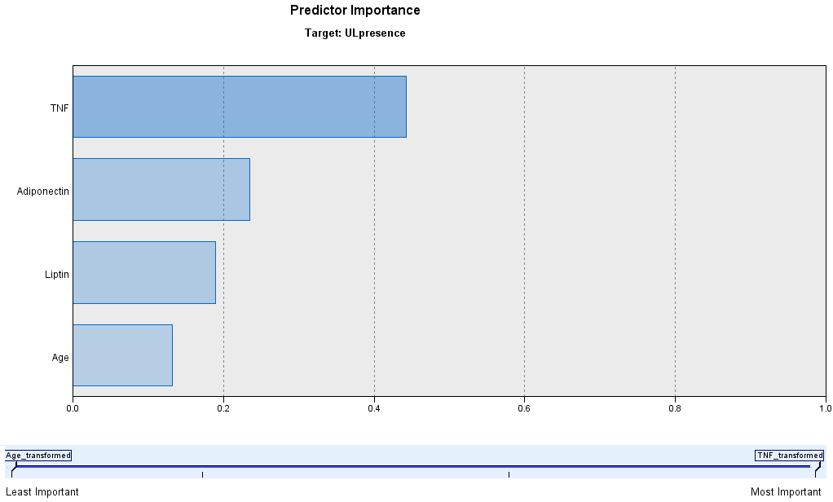

Fig. (4): Automatic Linear Modeling of patients' enrolment data and cytokines' levels as important predictors for the presence of UL.

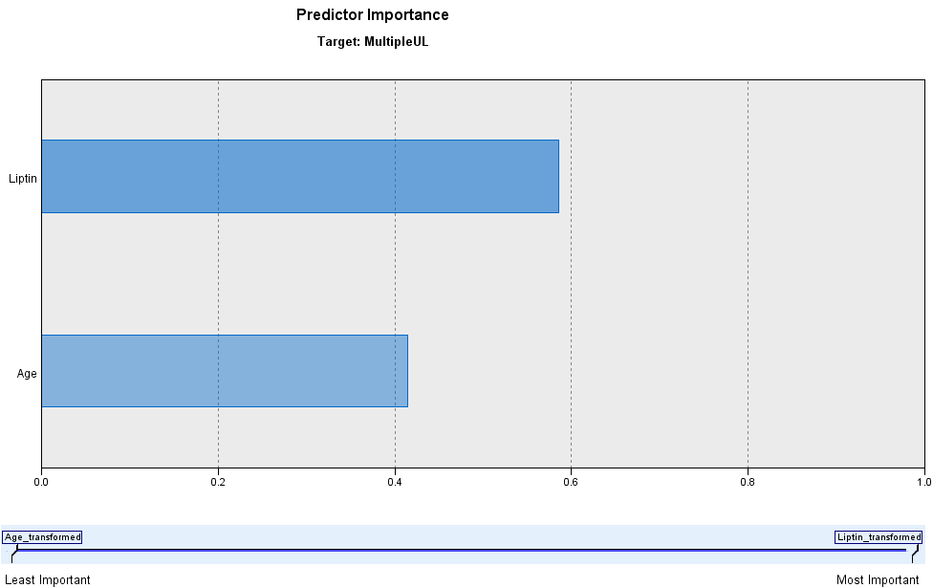
Fig. (5): Automatic Linear Modeling of patients' enrolment data and cytokines' levels as important predictors for a multiplicity of UL.

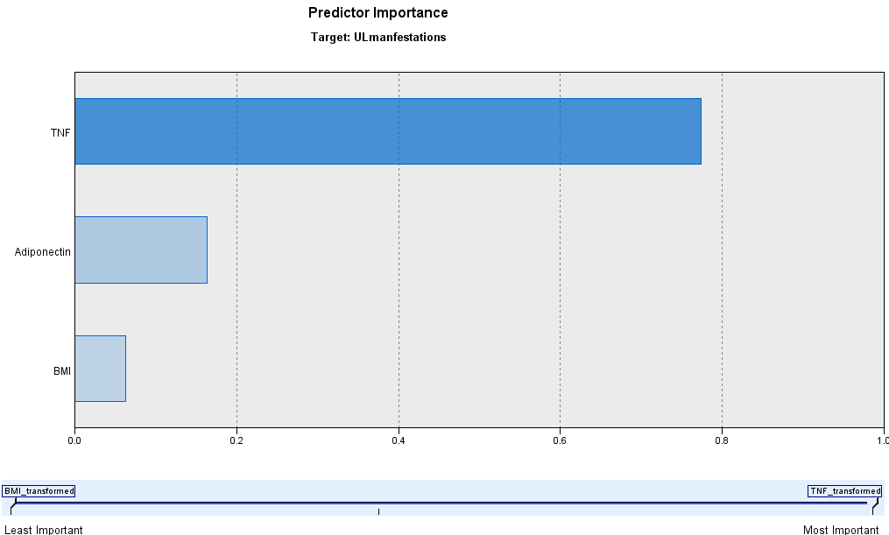
Fig. (6): Automatic Linear Modeling of patients' enrolment data and cytokines' levels as important predictors for the presence of symptomatic UL.

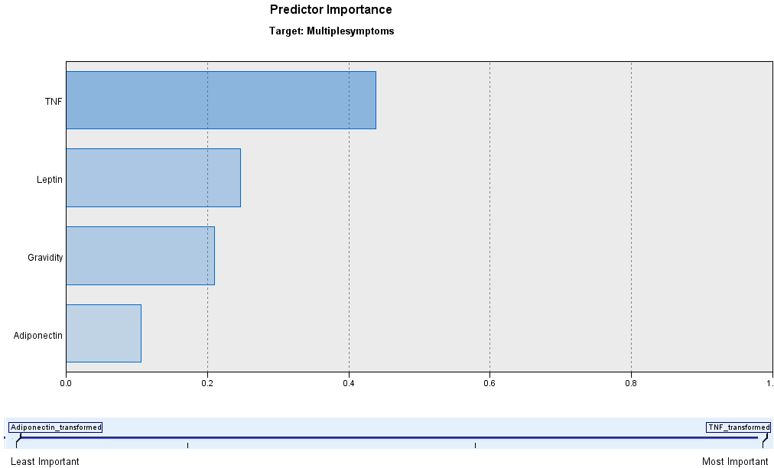
Fig. (7): Automatic Linear Modeling of patients' enrolment data and cytokines' levels as important predictors for the presence of multiple symptoms of UL.

Discussion
Uterine leiomyoma (UL) is frequent among women in the childbearing period irrespective of being symptomatic or asymptomatic as evidenced by the detection of UL in women who had asymptomatic UL who presented by recurrent pregnancy loss, secondary infertility, or pelvic pressure manifestations. Similarly, Sevostyanova et al. ⁽¹⁹⁾ documented that in women of reproductive age, typical symptoms of UL are associated with reproductive failure with activation of adaptive immunity, angiogenic factors, and inflammatory cell reactions.
Moreover, US imaging of women had asymptomatic UL detected uterine myomata sessile or pedunculated; submucous, subserous, or intramural with the non-significant difference in the frequency in comparison to women who had symptomatic UL. These findings go in hand with Szkodziak et al. ⁽²⁰⁾ who reported a frequency of UL of 20-50% and documented that these UL are mostly asymptomatic, and patients are usually present with pressure symptoms as pelvic pain syndrome, urination disorders, and constipation. Also, Spyropoulou et al. ⁽²¹⁾ in a systemic review for the coincidence of UL and pregnancy, found UL affects 2-10% of pregnant women and are usually asymptomatic, being subserous pedunculated or subserous and fundal, and may be associated with pregnancy complications. Recently, Gursoy et al. ⁽²²⁾ documented that UL has a prevalence of about 40% among women of reproductive age and are most often asymptomatic and presents with manifestations other than uterine bleeding.
Patients who had symptomatic UL mainly had presented by variant forms of abnormal uterine bleeding, despite the presence of pressure symptoms and secondary infertility, and recurrent pregnancy loss. These presenting manifestations are coincident with that previously documented by the North American Menopause Society ⁽²³⁾ and the recent Clinical Practice Guideline on the Management of Uterine Fibroids ⁽²⁴⁾ which documented that women with symptomatic UL experience heavy uterine bleeding, bulk symptoms, miscarriages, and pregnancy complications.
Estimated serum levels of adipocytokines showed significant differences between women who had UL and control women and women with symptomatizing UL than women who had asymptomatic UL. Moreover, there were significant correlations between estimated serum adipocytokines' levels and just presence of UL, the multiplicity of UL, and the presence and multiplicity of UL-related symptoms. These findings indicated a possible pathogenic role of disturbed adipocytokines' milieu for the development of UL and for the progression to be symptomatizing.
The detected significantly higher levels of serum leptin and significantly lower adiponectin levels in women had UL indicated a contradictory effect of both adipocytokines on the development of UL. In support of this assumption, Strzałkowska et al. ⁽²⁾ reported that under physiological conditions, leptin contributes to the formation of myomas, while adiponectin inhibits the development of leiomyomas through insulin-dependent or estrogen-dependent pathways. Meanwhile, the detected increased serum levels of TNF-α, which was found to contribute to the development of UL through inhibition of apoptosis with increased migration and fibrosis of leiomyomas ⁽²⁾, will disturb the equilibrium between leptin and adiponectin in direction of UL development and enlargement.
These findings and recently documented associations support the previous study which found the presence of inflammatory cells in UL may contribute to excessive extracellular matrix production, tissue remodeling, and leiomyoma growth through TNF-α induced increased expression of the pro-fibrotic factor activin-A mRNA in myometrial and leiomyoma cells ⁽²⁵⁾. Thereafter, another study suggested that TNF-α may be one of the key factors responsible for The transformation of the uterine smooth muscle cells into abnormal, immortal cells, capable of the clonal division leading to UL formation ⁽²⁶⁾. Experimentally, human endometrial stromal cells prepared from the endometrium of patients affected by UL were found to display higher TNF expression associated with increased expression of selective markers for the neuronal differentiation and the nerve growth factor in leiomyoma tissue in comparison to adjacent normal uterine tissues ⁽²⁷⁾. Recently, pathological fibrosis, which represents a typical feature of UL was attributed to an uncontrolled tissue repair secondary to dysregulation of macrophage proliferation, accumulation, and infiltration that was activated by increased TNF-α expression levels ⁽²⁸⁾.
The current study detected significantly higher serum TNF-α levels in women with symptomatic UL than in women who had asymptomatic UL with a positive significant correlation between serum TNF-α levels and presence and multiplicity of symptoms, which indirectly indicated the severity of affection. These results are coincident with that previously reported by Ciebiera et al. ⁽²⁹⁾ who detected a significant increase of serum TNF-α in women who had symptomatic UL in comparison to UL-free women and found elevated TNF-α serum concentration could be used as a predictor for ULs in selected populations. In support of the importance of estimation of serum TNF-α, Sevostyanova et al. ⁽¹⁹⁾ recommended estimation of serum TNF-α in pregravid preparation of women, including IVF program.
Despite the obtained results and previously documented relation between adipocytokines and development of UL, BMI showed no significant correlation with either the presence of UL or its related symptoms and considering the non-significant differences between BMI of the study and control women; thus certain women may have a higher susceptibility for the development of UL than others and this could be attributed to genetic background. In line with this assumption, Altinkaya et al., (2019) ⁽³⁰⁾ suggested that P72R/P72R genotype may be associated with the development of uterine leiomyoma. Ha et al. ⁽³¹⁾ found rs2239359 polymorphism, which causes a missense mutation in Fanconi anemia complementation group A, may be associated with the UL proliferation rate. Moreover, the rs1625895 (13494G>A) variant of the TP53 gene was associated with UL localization with patients who had the 13494GG genotype had significantly more often subserous UL, while patients with heterozygous variant (13494GA genotype) had more often intramural UL ⁽³²⁾.

Conclusion:
The prevalence of UL is high and may not be present by AUB but disturbed fertility. Development of UL might be considered as a consequent event to disturbed adipocytokines levels. Estimation of serum TNF-α in women suspected to have UL is highly indicated for its diagnostic probability and its relation to a multiplicity of symptoms.

Limitation
The study was limited to being observational study and follow-up of these women who had UL after interferences were needed to determine the prognostic ability of estimation of these cytokines especially for women who had uterus preserving interferences.

References
- Shi S, Ye Q, Yu C, Peng F: The efficacy and safety of Xuefu Zhuyu Decoction combined with Mifepristone in the treatment of uterine leiomyoma: A systematic review and meta-analysis. J Ethnopharmacol. 2021 Dec 5; 281:114551. Doi: 10.1016/j.jep.2021.114551.
- Strzałkowska B, Dawidowicz M, Ochman B, Świętochowska E: The role of adipokines in leiomyomas development. Exp Mol Pathol. 2021 Dec; 123:104693. Doi: 10.1016/j.yexmp.2021.104693.
- Elkafas H, Ali M, Elmorsy E, Kamel R, Thompson W, Badary O, Al-Hendy A, Yang Q: Vitamin D3 Ameliorates DNA Damage Caused by Developmental Exposure to Endocrine Disruptors in the Uterine Myometrial Stem Cells of Eker Rats. Cells. 2020 Jun 12;9(6):1459. Doi: 10.3390/cells9061459.
- Lee J, Jeong Y, Mok S, Choi K, Park J, Moon H, Choi G, Kim H, Kim S, Choi S, Kim S: Associations of exposure to phthalates and environmental phenols with gynecological disorders. Reprod Toxicol. 2020 Aug; 95:19-28. Doi: 10.1016/j.reprotox.2020.04.076.
- Li S, Chen B, Sheng B, Wang J, Zhu X: The associations between serum vitamin D, calcium and uterine fibroids in Chinese women: a case-controlled study. J Int Med Res. 2020 May;48(5):300060520923492. Doi: 10.1177/0300060520923492.
- Mohammed N, Al-Taie A, Albasry Z: Evaluation of goserelin effectiveness based on assessment of inflammatory cytokines and symptoms in uterine leiomyoma. Int J Clin Pharm. 2020 Jun;42(3):931-937. Doi: 10.1007/s11096-020-01030-3.
- Micheau O: TRAIL, Fas Ligand, TNF and TLR3 in Cancer. Berlin: Springer. 10.1007/978-3-319-56805-8 (2017).
- Yi F, Frazzette N, Cruz A, Klebanoff C, Siegel R: Beyond cell death: new functions for TNF family cytokines in autoimmunity and tumor immunotherapy. Trends Mol. Med. 24, 642–653. 10.1016/j.molmed.2018.05.004 (2018).
- Kaluza W, Reuss E, Grossmann S, Hug R, Schopf R, Galle P, Maerker-Hermann E, T Hoehler: Different transcriptional activity and in vitro TNF-alpha production in psoriasis patients carrying the TNF-alpha 238A promoter polymorphism. J Invest Dermatol. 2000 Jun;114(6):1180-3. Doi: 10.1046/j.1523-1747.2000.00001. x.
- Takasugi K, Yamamura M, Iwahashi M, Otsuka F, Yamana J, Sunahori K, Kawashima M, Yamada M, Makino H: Induction of tumor necrosis factor receptor-expressing macrophages by interleukin-10 and macrophage colony-stimulating factor in rheumatoid arthritis. Arthritis Res Ther. 2006; 8(4): R126. Doi: 10.1186/ar2015.
- Korobowicz A: Biology of tumor necrosis factor type alpha (TNF-alpha). Pol Merkur Lekarski. 2006 Oct;21(124):358-61.
- Micheau O, Rizzi M, Smulski C: Editorial TNFR Superfamily Oligomerization and Signaling. Front Cell Dev Biol. 2021 Apr 20; 9:682472. Doi: 10.3389/fcell.2021.682472.
- Nair S, Nguyen H, Salama S, Al-Hendy A: Obesity and the Endometrium: Adipocyte-Secreted Proinflammatory TNF α Cytokine Enhances the Proliferation of Human Endometrial Glandular Cells. Obstet Gynecol Int. 2013; 2013:368543. Doi: 10.1155/2013/368543.
- Nair S, Al-Hendy A: Adipocytes enhance the proliferation of human leiomyoma cells via TNF-α proinflammatory cytokine. Reprod Sci. 2011 Dec;18(12):1186-92. Doi: 10.1177/1933719111408111.
- Yadav N, Barcikowski A, Uehana Y, Jacobs A, Connelly L: Breast Adipocyte Co-culture Increases the Expression of Pro-angiogenic Factors in Macrophages. Front Oncol. 2020 Apr 7; 10:454. Doi: 10.3389/fonc.2020.00454.
- Coughlan M, Oliva K, Georgiou H, Permezel J, Rice G: Glucose-induced release of tumor necrosis factor-alpha from human placental and adipose tissues in gestational diabetes mellitus. Diabet Med. 2001; 18:921–7.
- Yokota T, Oritani K, Takahashi I, Ishikawa J, Matsuya-ma A, Ouchi N, Kihara S, Fu-nahashi T, Tenner A: Adiponectin, a new member of the family of soluble defense collagens, negatively regulates the growth of mye-lomonocytic progenitors and the func-tions of macrophages. Blood., 96, 1723-1732 (2000).
- Havel P, Kasim-Karakas S, Dubuc G, Muller W, Phinney S: Gender difference in plasma leptin concentration. Nature Med.; 2:949-50 (1996).
- Sevostyanova O, Lisovskaya T, Chistyakova G, Kiseleva M, Sevostyanova N, Remizova I, Buev Y: Proinflammatory mediators and reproductive failure in women with uterine fibroids. Gynecol Endocrinol. 2020;36(sup1):33-35. Doi: 10.1080/09513590.2020.1816726.
- Szkodziak P, Pyra K, Szkodziak F, Krzyżanowski J, Czuczwar P, Woźniak S, Jargiełło T, Paszkowski T: The Lublin Protocol of the Uterine Arteries Embolization in the Treatment of Symptomatic Uterine Fibroids J Vis Exp. 2020 Sep 15;(163). Doi: 10.3791/61530.
- Spyropoulou K, Kosmas I, Tsakiridis I, Mamopoulos A, Kalogiannidis I, Athanasiadis A, Daponte A, Dagklis T: Myomectomy during pregnancy: A systematic review. Eur J Obstet Gynecol Reprod Biol. 2020 Nov; 254:15-24. Doi: 10.1016/j.ejogrb.2020.08.018.
- Gursoy A, Cakmak D, Akgul G, Kiseli M, Umudum H, Pabuccu R, Caglar G: The assessment of the relationship between the vascularity of FIGO Type 4-7 leiomyomas and abnormal uterine bleeding. J Obstet Gynaecol. 2021 May 3;1-5. Doi: 10.1080/01443615.2021.1882969.
- The North American Menopause Society (NAMS): NAMS 2018 Utian Translational Science Symposium, October 2018, San Diego, California New therapies for leiomyomas: when surgery may not be the best option. Menopause. 2019 Sep;26(9):947-957. doi: 10.1097/GME.0000000000001402.
- Laberge PY, Murji A, Vilos GA, Allaire C, Leyland N, Singh SS: Guideline No. 389-Medical Management of Symptomatic Uterine Leiomyomas - An Addendum. J Obstet Gynaecol Can. 2019 Oct;41(10):1521-1524. doi: 10.1016/j.jogc.2019.01.010.
- Protic O, Toti P, Islam M, Occhini R, Giannubilo S, Catherino W, Cinti S, Petraglia F, Ciavattini A, Castellucci M, Hinz B, Ciarmela P: Possible involvement of inflammatory/reparative processes in the development of uterine fibroids. Cell Tissue Res. 2016 May;364(2):415-27. Soi: 10.1007/s00441-015-2324-3.
- Ciebiera M, Włodarczyk M, Zgliczyńska M, Łukaszuk K, Męczekalski B, Kobierzycki C, Łoziński T, Jakiel G: The Role of Tumor Necrosis Factor α in the Biology of Uterine Fibroids and the Related Symptoms. Int J Mol Sci. 2018 Dec 4;19(12):3869. Doi: 10.3390/ijms19123869.
- Luddi A, Marrocco C, Governini L, Semplici B, Pavone V, Capaldo, A Tosti C, Greco S, Luisi S, Ciarmela P, Petraglia F, Piomboni P: Increased expression of neurogenic factors in uterine fibroids. Hum Reprod. 2019 Nov 1;34(11):2153-2162. Doi: 10.1093/humrep/dez182.
- Zannotti A, Greco S, Pellegrino P, Giantomassi F, Carpini G, Goteri G, Ciavattini A, Ciarmela P: Macrophages and Immune Responses in Uterine Fibroids. Cells. 2021 Apr 22;10(5):982. Doi: 10.3390/cells10050982.
- Ciebiera M, Włodarczyk M Wrzosek M, Wojtyła C, Błażej M, Nowicka G, Łukaszuk K, Jakiel G: TNF-α serum levels are elevated in women with clinically symptomatic uterine fibroids. Int J Immunopathol Pharmacol. Jan-Dec 2018; 32:2058738418779461. Doi: 10.1177/2058738418779461.
- Altinkaya S, Avcioglu S, Sezer S, Ceylaner S: Analysis of TP53 gene in uterine myomas: No mutations but P72R polymorphism is associated with myoma development. J Obstet Gynaecol Res. 2019 Oct; 45(10):2088-2094. Doi: 10.1111/jog.14071.
- Ha E, Lee S, Lee S, Jung J, Chung H, Choi E, Kwon S, Cha M, Shin S: FANCA Polymorphism Is Associated with the Rate of Proliferation in Uterine Leiomyoma in Korea. J Pers Med. 2020 Nov 13;10(4):228. Doi: 10.3390/jpm10040228.
- Kornatska A, Flaksemberg M, Chubei G, Trokhymovych O, Rossokha Z, Fishchuk L, Medvedieva N, Vershyhora V, Gorovenko N: A variant of TP53 gene (rs 1625895, 13494g>A) is associated with neoplasm localization in patients with uterine leiomyoma. Exp Oncol. 2021 Jun;43(2):155-158. Doi: 10.32471/exp-oncology.2312-8852.vol-43-no-2.16195.

